1.
Boil a kettle
Slice the waxy potatoes (skins on) into 1-2 cm thick discs
Add the vegetable stock mix to a large pot of boiled water and bring to a boil over a high heat
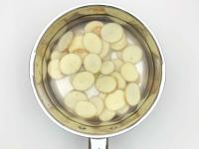
2.
Add the potato discs to the pot and cook for an initial 4 min
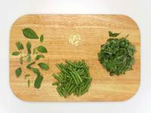
3.
While the potatoes are cooking, chop the basil roughly, including the stems (save some leaves for garnish!)
Peel and chop the garlic roughly
Trim, then chop the green beans in half
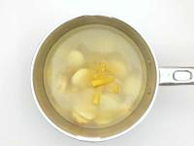
4.
Add the tortiglioni to the pot and cook for a further 8 min
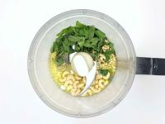
5.
Whilst the potatoes & tortiglioni are cooking, add the chopped basil and garlic (don't like raw garlic? Go easy!) to a food processor
Add the cashew nuts, half the pine nuts (save some for garnish!), 70ml [140ml] olive oil, 1/2 tsp [1 tsp] salt and a very generous grind of black pepper
Blitz until very smooth – this is your basil pesto
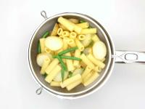
6.
Add the halved green beans to the potatoes & tortiglioni and cook for a further 5 min or until everything is cooked
Once cooked, drain the potatoes, green beans & tortiglioni
Return everything to the pot
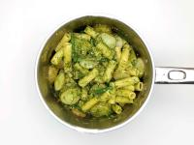
7.
Add the basil pesto to the pot and give everything a good mix up – this is your pasta alla genovese
Serve the pasta alla genovese in bowls and garnish with the reserved basil leaves and pine nuts
Drizzle with some olive oil and season with a grind of black pepper
Enjoy!

